**Homework 4: Tableau**

Provakar Mondal

**Problem 1:**

From my perspective, I think a Horizontal bar chart is an appropriate visualization to examine the distribution of how much each country has been attacked, how the number of attacks might be concentrated in a few countries, and how the number of attacks drops off from most to least attacked countries. Image of the corresponding Horizontal bar chart below.

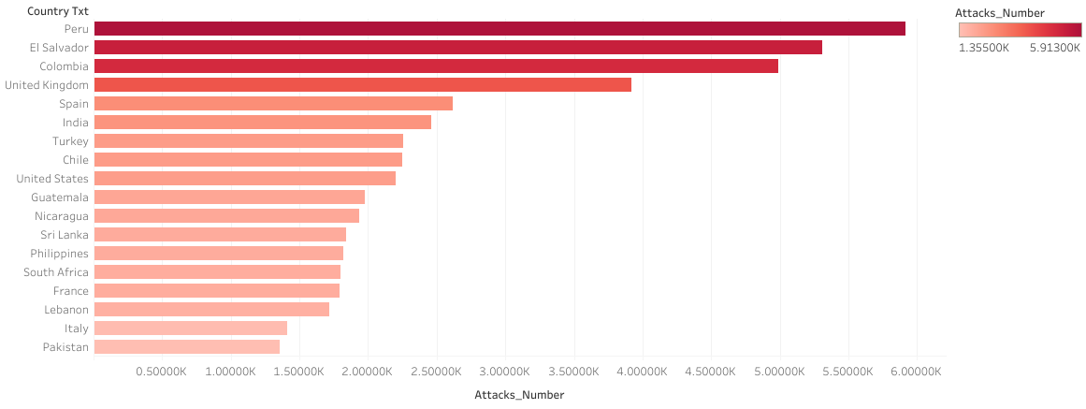

From this chart, we can get the idea that Peru has been attacked most times (5913), then El Salvador (5311) and other countries according to their descending order of position of attacks number. The dense red color has also indicated the most attacked countries, thus it has been visualized how attacks have been concentrated in few countries.

The distribution of the shape can also be described from the chart.

Maximum attacks number = 5913

Minimum attakcs number = 1

Range = 5913 - 1 = 5912

As the chart is sorted in descending order, the high color density countries based on attack numbers are placed at top of the chart. Gradually the slope of the shape decreased and as the range is a very high value at the last point the slope value has been almost 0.

The above picture is a cropped one for the purpose of well understanding and ease for understanding. The picture of the complete bar chart has been attached here.

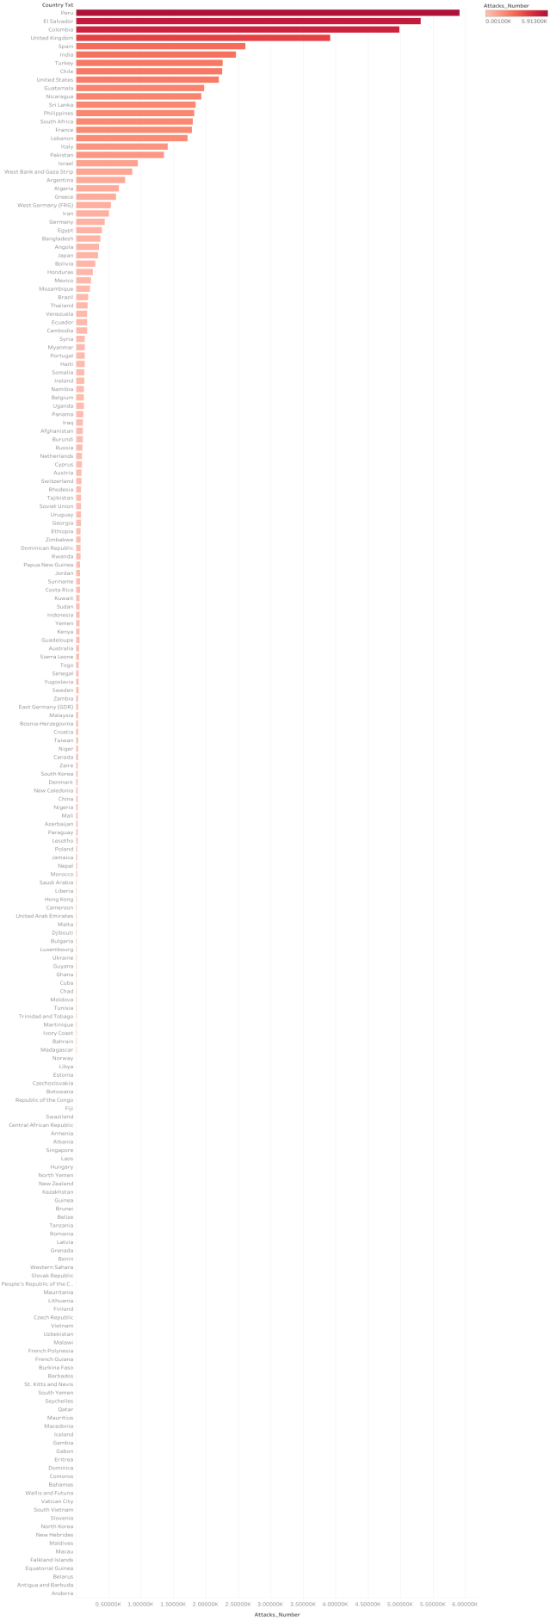

**Problem 2:**

Here are the sparklines that visualize the temporal trends of the number of attacks in each country over time.

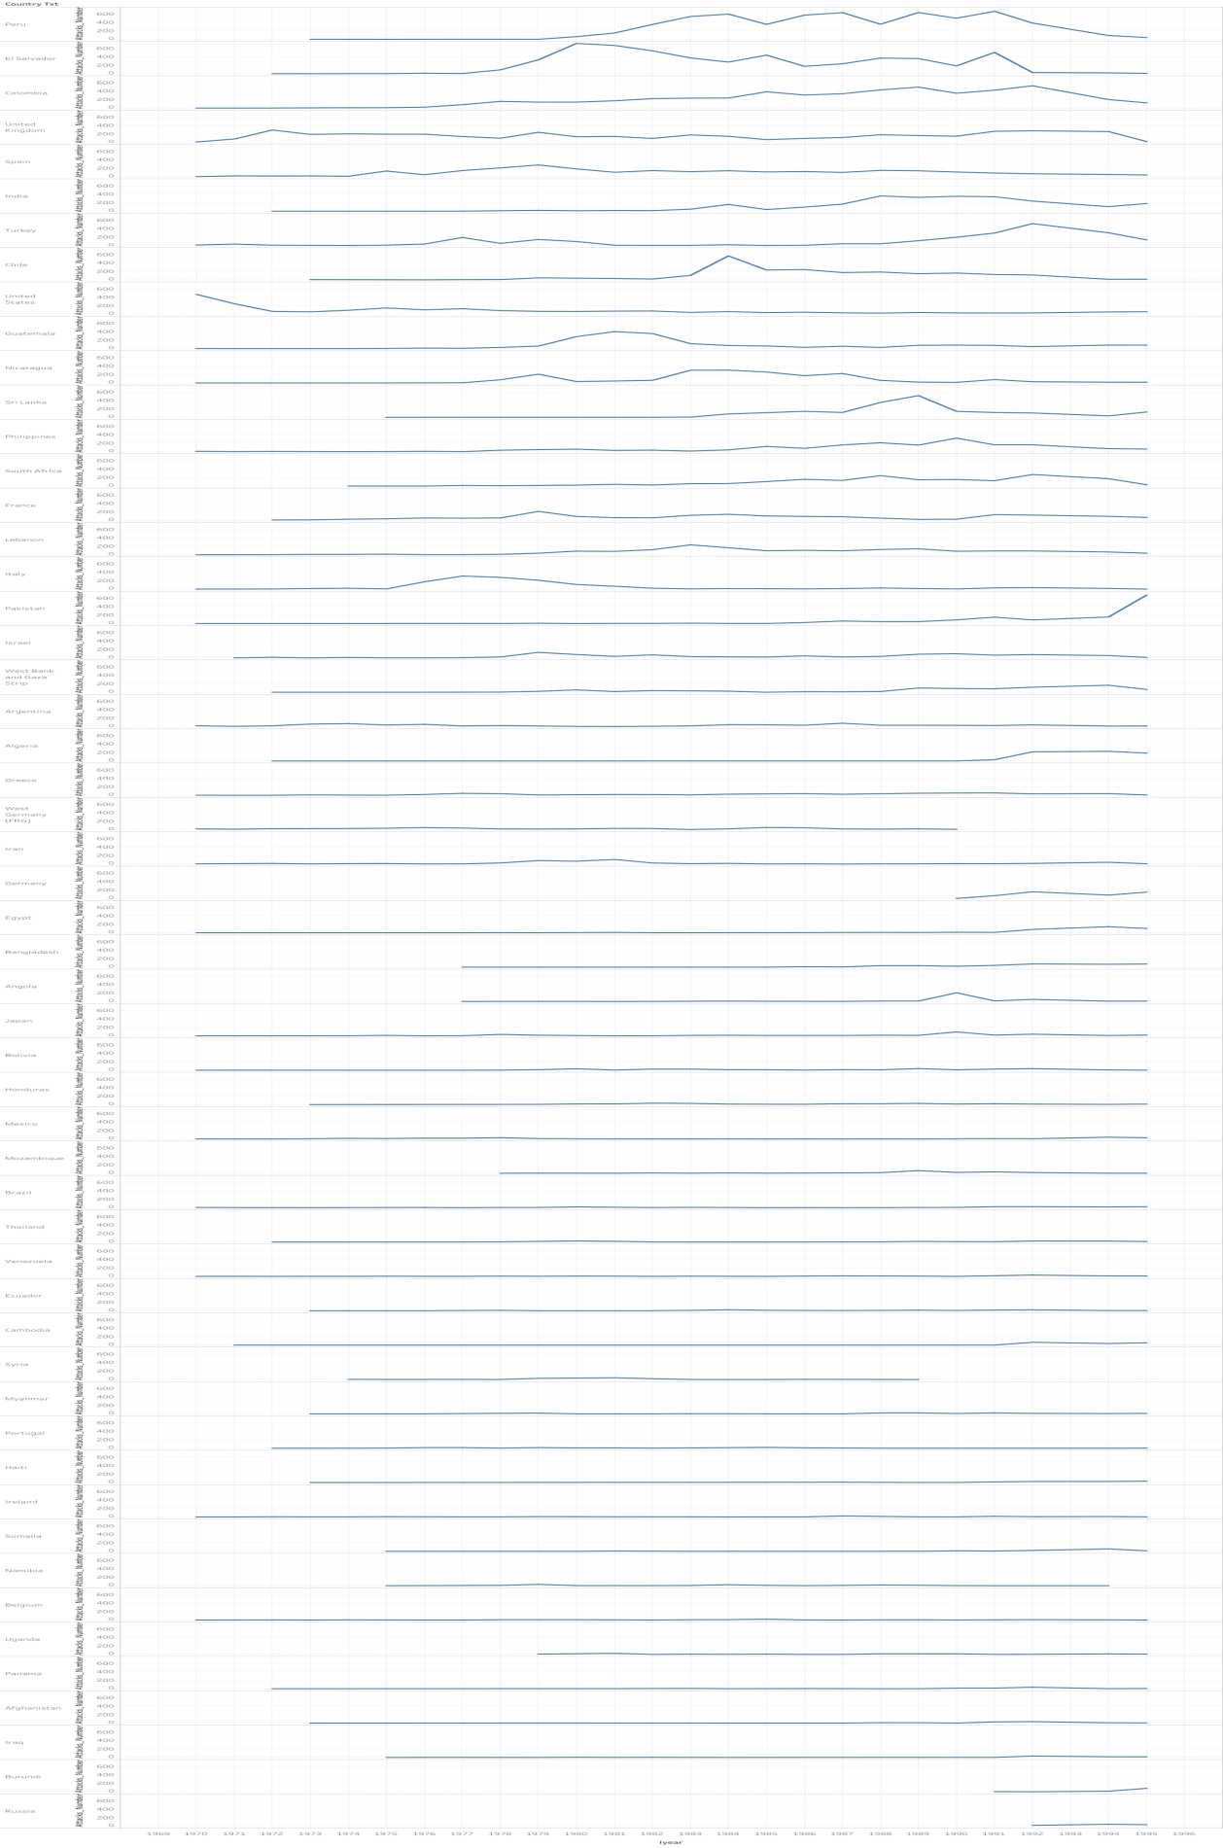

From this chart, one interesting thing that seems to me is that in Peru the number of attacks was small till 1981. Then the number of attacks increased on high exponential but after 1991 number of attacks reduced gradually. It seems that the government between 1981 to 1991 was not good enough to protect the country from terrorism. To support my guess I searched on the internet and the result I found made me shocked. Actually, this decade is called **Lost Decade** or the **Crisis of the 80s**and during this decade [foreign debt accumulation](https://en.wikipedia.org/wiki/Latin_American_debt_crisis" \t "/home/provakar/Documents\\x/_blank) throughout Latin America, a series of [natural disasters](https://en.wikipedia.org/wiki/Natural_disaster" \t "/home/provakar/Documents\\x/_blank), mass [public expenditures](https://en.wikipedia.org/wiki/Public_expenditure" \t "/home/provakar/Documents\\x/_blank), nationalizations of banks and financial institutions, and the shutting of Peru out of international credit markets led to a decade of macroeconomic decline. There is already a wiki page on this [Reference: [Lost Decade (Peru)](https://en.wikipedia.org/wiki/Lost_Decade_(Peru))].

The full chart is too large to read the text that’s why here I have attached a portion of the spark from the top.

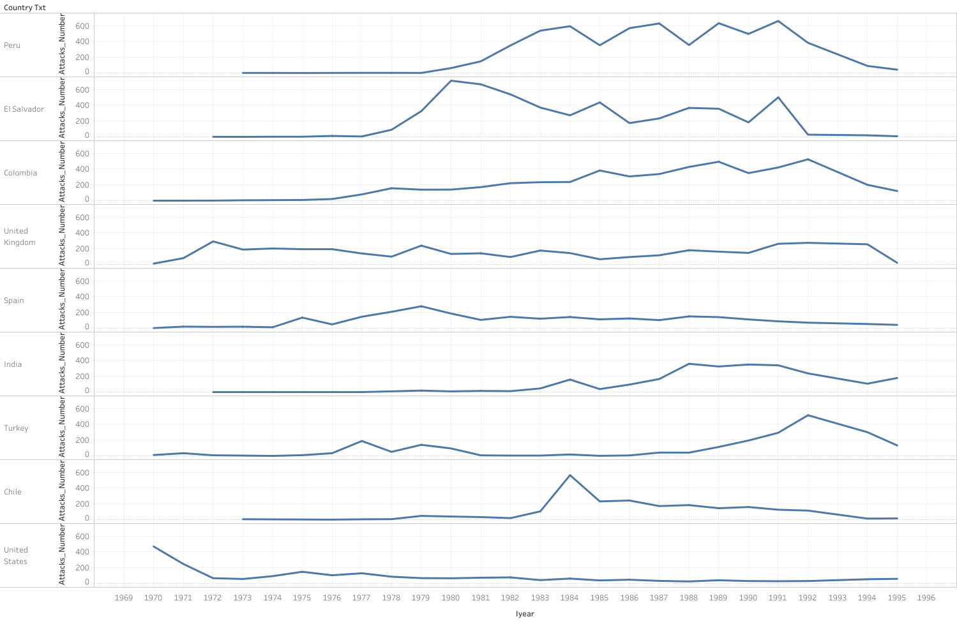

**Problem 3:**

**Question:** Make an appropriate visualization that depicts how the number of **Attacktype1**has dropped off from most to least based on regions. Also, enable the visualization so that it can discriminate the types of attacks from **Attacktype1**.

**Answer:**I think a Stacked bar chart is an appropriate visualization to fulfill the criteria of the question. Here I have attached the stacked bar chart that tells how the regions are attacked by the number of **Attacktype1**. It also makes visualization differences of types of attack from **Attacktype1**by using different colors.

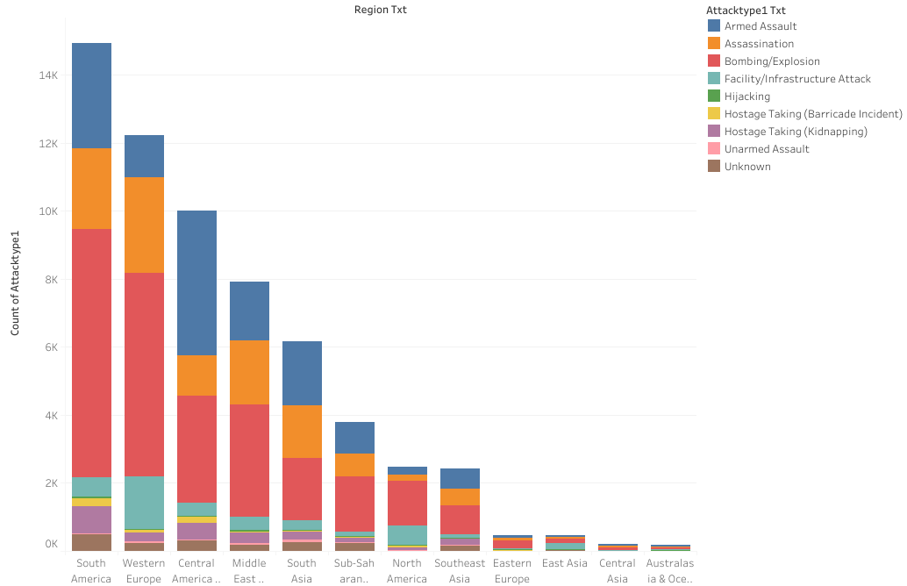

So from the stacked bar chart, we see that South America is the most affected country for **Attacktype1**. Western Europe is in the second position. Besides, one more thing that is common to all is that among the types of attack, Bombing/Explosion has taken place the most times. After that Armed Assault is in the second position in some regions, in some regions Assasiantion posses the second position.